**Electronic Team Project Notebook**

Team 59

Ryan Hellyer

Kathryn Atherton

Natalie Zimmermann

**Meeting Minutes**

Monday, October 19th 2015:

-Started project 2 in class and worked on identifying the different variables related to the cost of utilizing 3D printer:

1. Material used
2. Cost of the material
3. Time needed to produce a part
4. Speed of the printer
5. Cost of labor
6. Cost of energy

-Electronic signatures:

* Natalie Zimmermann
* Ryan Hellyer
* Kathryn Atherton

Wednesday, October 21st 2015

**Data cleaning activity**

-Kathryn Atherton absent due to illness

-Print Head Speed vs. Dimensional Error

1.- Points with speed 0: Removed because no error if you are not moving (printer tested previous samples without actually moving)

2.- Adjusted error column subtracting .1 from all the Absolute Error values, because comparing with known results showed that it was not properly calibrated and therefore the offset was consistently 0.1 to high.

3.- Delete data at point (1.850, 1.105 ) because the intern tripped into the machine and skewed the data

4.- Delete points 57 and 58 because of leak occurred during that time and we do not know how it actually influenced the performance

-Print Aperture vs. Dimensional Error

1.- Added 0.1 to the Print Aperture column, because values were negative, which indicates calibration error

2.- Deleted points were aperture was 0, as they did not indicate anything about the actual performance of the printer

-Culture Temperature vs. Dimensional Error

1.- Deleted data points 16 through 18 because intern was doing jumping jacks in the lab, and messed with the results

2- Deleted data point 123, extremely high error due to the room shaking because heavy objects were transported

3.- Deleted data points before 4ºC and after 36ºC, as the model does not apply for values out of the range [4, 36].

-Electronic signatures:

* Ryan Hellyer
* Natalie Zimmermann

Friday, October 23rd 2015

* In-class work on Method of Selected Points
* Used technique learned in class to model graphs from Activity 2 from Wednesday
* Kathryn Atherton absent due to illness
* Electronic signatures:
  + Natalie Zimmermann
  + Ryan Hellyer

Monday, October 26th 2015

* In-class work on Least Squares Method
* Used technique learned in class to model graphs from Activity 2 from Wednesday (10/21/2015)
* Team looked for connections between the different equations and the input values from the user
* Team established relationships between different variables
* Team reviewed materials used in Bio Printing and their cost
* Electronic signatures:
  + Natalie Zimmermann
  + Ryan Hellyer
  + Kathryn Atherton

Wednesday, October 27th 2015

* Team met in the evening to discuss the organization of Project 2
* Team elaborated on the relationship and correlation between the different variables that influence the Bioprinter and established mathematical models
* Team started working in the Python Code for the Bioprinter, taking into account the different input and output values
* Electronic Signatures:
  + Ryan Hellyer
  + Natalie Zimmermann
  + Kathryn Atherton

Representation of relationship between variables:

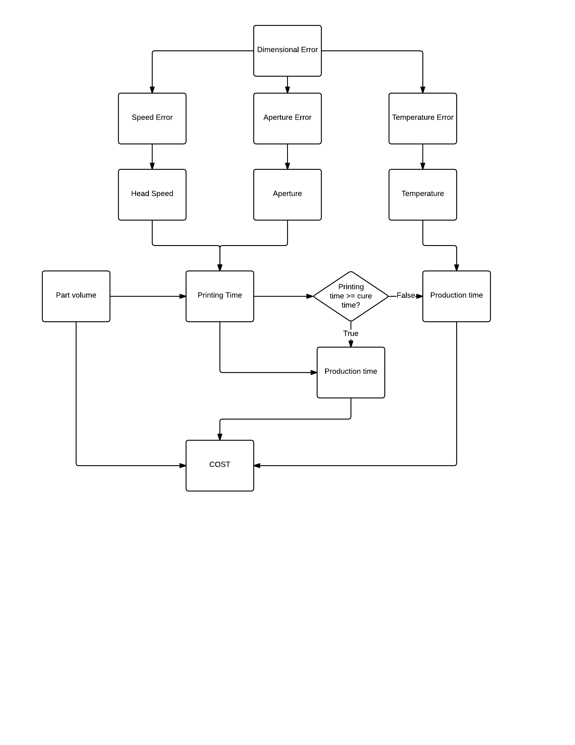

|  |  |  |  |  |  |  |  |  |  |  |
| --- | --- | --- | --- | --- | --- | --- | --- | --- | --- | --- |
|  | DE | SE | AE | TE | Speed | Apert | Temp | Vol. | Print time | Cost |
| DE |  | + | + | + | + | + | + |  | - | - |
| SE | + |  |  |  | + |  |  |  | - | - |
| AE | + |  |  |  |  | + |  |  | - | - |
| TE | + |  |  |  |  |  | + |  | - | - |
| Speed | + | + |  |  |  |  |  |  | - | - |
| Apert | + |  | + |  |  |  |  |  | - | - |
| Temp | + |  |  | + |  |  |  |  | - | - |
| Vol |  |  |  |  |  |  |  |  | + | + |
| Print time | - | - | - | - | - | - | - | + |  | + |
| Cost | - | - | - | - | - | - | - | + | + |  |

Legend

DE: Dimensional Error | SE: Speed Error | AE: Aperture Error | TE: Temperature Error

+ : Variables are directly proportional | - : Variables are inversely proportional

Wednesday, October 28th 2015

* Ryan Hellyer absent
* In-Class work on project 2
* Introduced the concept of “Factor of Safety”
* Related “Factor of Safety” to Project 2
  + Tolerance is input by the user
  + Tolerance is going to be the maximum value our model can attain
  + Factor of Safety = Tolerance / Dimensional Error
  + Going to aim for the Dimensional Error
* Team continued to work on the main program
* Electronic Signatures:
  + Natalie Zimmermann
  + Ryan Hellyer

Saturday, October 31st 2015

* Team met to finish the computer program/mathematical model of the Bio-Printer
* Worked on the Method of Least Squares Program
  + Used method of Least Squares for calculating linear regressions
  + Used MLS to find the relationship between the data obtained from the NHI Dimensional Error vs. Print Head Speed
* Calculated the recommended Factor of Safety for each part
* Started the presentational poster for Peer Review on Monday
  + Introduction
  + Methods
  + Discussion
  + Results
* Electronic Signatures
  + Natalie Zimmermann
  + Kathryn Atherton
  + Ryan Hellyer

Monday, November 2nd 2015

IN CLASS:

* Kathryn Atherton absent due to illness
* Peer poster review with constructive feedback:
  + Too much text
  + Use a larger font
  + Larger legend for the relationship between variables graph
  + Add more information into conclusion section
  + How was the Method of Least Squares applied?
* Worked on the poster
* Reviewed the mathematical model/code
* Electronic Signatures:
  + Natalie Zimmermann
  + Ryan Hellyer

EVENING MEETING:

* Kathryn Atherton absent due to illness
* Reviewed Mathematical model/code
  + Found mistakes in unit conversions
  + Reviewed outputs for all the given common products
* Finished poster
  + Implemented recommendations from peer review
* Electronic Signatures:
  + Natalie Zimmermann
  + Ryan Hellyer

Tuesday, November 3rd 2015

* Divided up the poster to present
* Started Work on Executive Summary
  + Finished Cover Letter
  + Finished Executive Summary
  + Finished Model Development Process
  + Still have add graphs, images, equations
* Electronic Signatures:
  + Natalie Zimmermann
  + Kathryn Atherton
  + Ryan Hellyer

Wednesday, November 4th 2015

* In-class presentation of the poster and model
* Peer evaluation of the poster and models
* Reflection about lessons learned from Project 2
* Final poster presented:

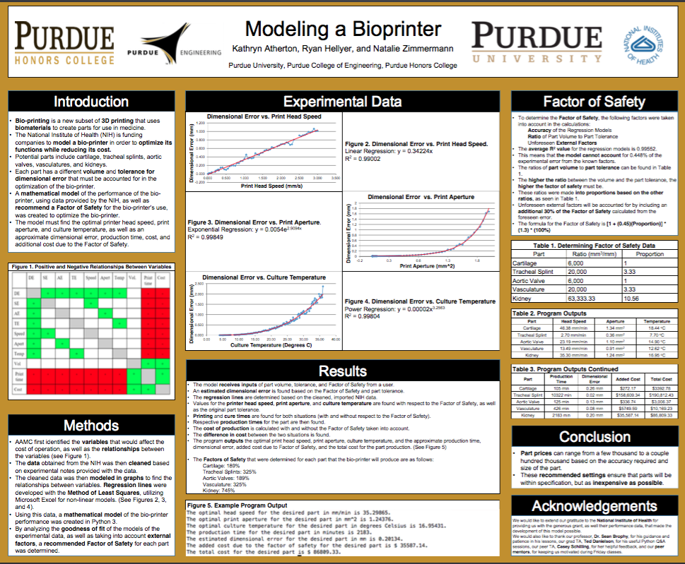

* Electronic Signatures:
  + Natalie Zimmermann
  + Kathryn Atherton
  + Ryan Hellyer

Thursday, November 5th 2015:

* Worked on Recommendations and Conclusions
  + Why did we choose that factor of safety?
  + Who can use printer in the future
  + Why more research?
* Included Appendix and Reference List
* Graphs, tables, and figures that were included in the poster presentation, or needed during the model development process were included in the document
* Electronic Signatures:
  + Natalie Zimmermann
  + Kathryn Atherton
  + Ryan Hellyer

**Methods**

•AAMC first identified the variables that would affect the cost of operation, as well as the relationships between the variables (see Figure 1).

•The data obtained from the NIH was then cleaned based on experimental notes provided with the data.

•The cleaned data was then modeled in graphs to find the relationships between variables. Regression lines were developed with the Method of Least Squares, utilizing Microsoft Excel for non-linear models. (See Figures 2, 3, and 4).

•Using this data, a mathematical model of the bio-printer performance was created in Python 3.

•By analyzing the goodness of fit of the models of the experimental data, as well as taking into account external factors, a recommended Factor of Safety for each part was determined.

**Factor of Safety Rationale**

•To determine the Factor of Safety, the following factors were taken into account in the calculations:

-Accuracy of the Regression Models

-Ratio of Part Volume to Part Tolerance

-Unforeseen External Factors

•The average R2 value for the regression models is 0.99552.

•This means that the model cannot account for 0.448% of the experimental error from the known factors.

•A ratio of this unaccountable error versus the average R2 value was taken (0.45) and incorporated into the formula.

•The ratios of part volume to part tolerance can be found in Table 1.

•The higher the ratio between the volume and the part tolerance, the higher the factor of safety must be.

•These ratios were made into proportions based on the other ratios.

•Unforeseen external factors will be accounted for by including an additional 30% of the Factor of Safety calculated from the foreseen error.

•The formula for the Factor of Safety is [1 + (0.45)(Proportion)] * (1.3) * (100%)

**Findings and Test Cases**

The following values for each variable for the given parts were calculated by the model developed by the team.

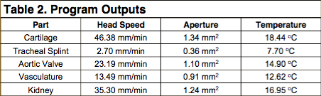

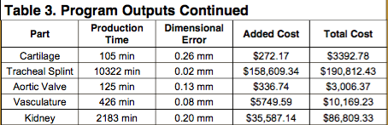

**Assumptions**

* The head speed, print aperture, and culture temperature were the only factors that affected dimensional error.
* The head speed, print aperture, and culture temperature can be directly found from the estimated dimensional error, rather than cumulatively contributing to the dimensional error.